Great Plains Web Service 2010/13 Setup

Installing Web Service
Run the main MS Dynamics GP installer, from the menu of available options, click on web services to install the web service components. If eConnect is not installed, installing web services will automatically install eConnect – so a separate installation is not required. Follow the WSInstallGuide.pdf for detailed steps associated with installing the web service. The most important things to consider are (in addition to GP2010/13) -
- Restart the server
- Make sure the installation files for GP and GP web services are same. A lot of times users had a higher service pack in production, but still end up downloading the RTM version for installing web services.
- Each web service installation service pack comes with its own installation PDF called WSInstallGuide.pdf, please verify all pre-requisites on that PDF are installed. You may not need Active Directory Light Weight Role, if you are not migrating from GP 10.

During installation, the installer will prompt to create a web service security database. Provide any name like DynamicsGPSecurity and complete the installation.
After installing the web services, the web service configuration wizard starts automatically. Please refer the WSInstallGuide.pdf (Chapter 4 – Initial Configuration of Web Services Section) for the steps involved. Make sure the ISO codes for currencies are setup. Click next till you finish the installation.
If the web service configuration wizard does not start automatically, you can start by going to Start->All Programs->MS Dynamics -> Web Service for MS Dynamics->GP Web Service Configuration Wizard
Run the web services management tools setup from the main MS Dynamics GP Installer menu.
To verify installation, Go to Start-> All Programs -> Admin Tools - > Services do the following
- Verify if “Microsoft Dynamics GP Service Host” is installed and running
- Verify if “eConnect for Microsoft Dynamics” is installed and running.
Next, we need to verify if that Dynamics GP Service Legacy endpoint is up and running. This can be done by making sure the following pages load up –
Dynamics GP Web Service - http://<MachineName>:48620/DynamicsGPWebServices/DynamicsGPService.asmx or http://<MachineName>:48620/DynamicsGPWebServices
Dynamics Admin Service - http://<MachineName>:48621/DynamicsAdminService.asmx or http://<MachineName>:48621

Configuring Security Roles
Go to Administrative Tools - > Dynamics Security Console
Actions-> Select Applications - > Security Admin Service - > Security Service - > Check Dynamics GP Web Service - > Click OK.
Expand Microsoft Dynamics Security - > DynamicsGPWebServices-> Role Assignments -> Add and Select the windows user who will be responsible for running the Gorilla Expense Integration Manager to post invoices to GP.
Also, select the desired company.
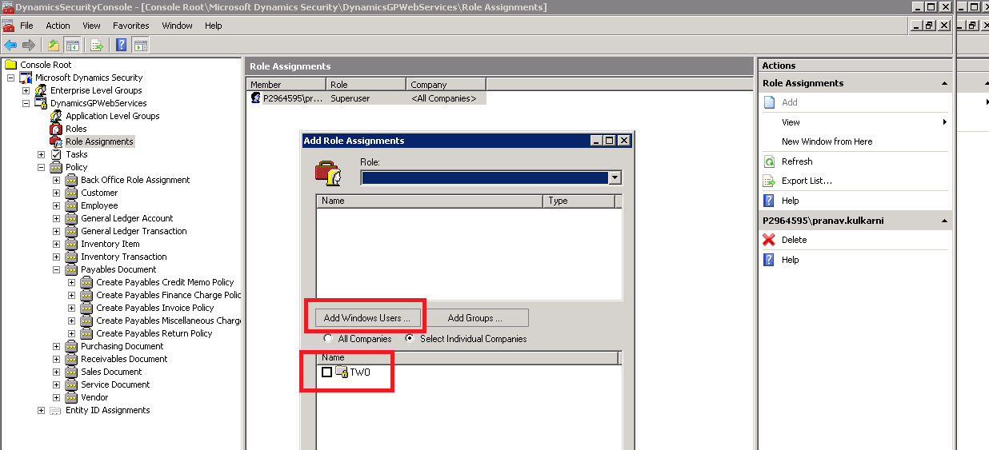
Now, go ahead and select the Role as “Accounts Payable Coordinator” or “SuperUser”

Configuring “Create Payables Invoice Policy”
Go to Administrative Tools - > Dynamics Security Console -> MicrosoftDynamicsSecurity - > DynamicsGPWebServices-> Policy ->Payables Document -> Create Payables Invoice Policy
Make sure Create GL Account Distribution Behavior is set to “Distribution Will be provided”
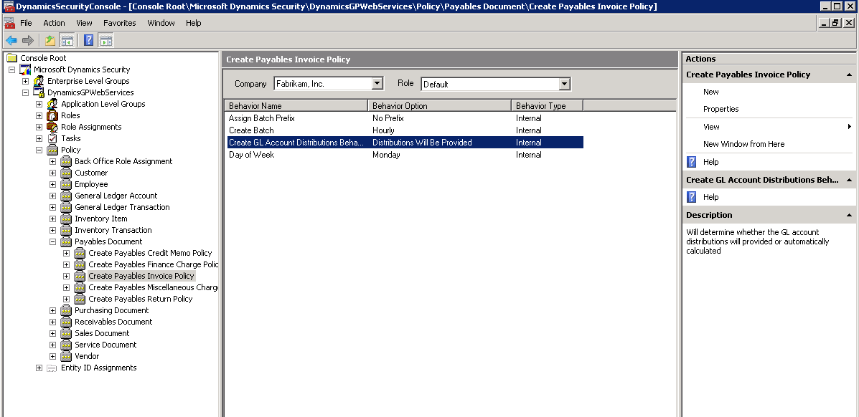
The default is “Automatically Create Distribution”. Click on properties link on the right side of the above window. You will be then presented with the following window where you could change the distribution type.
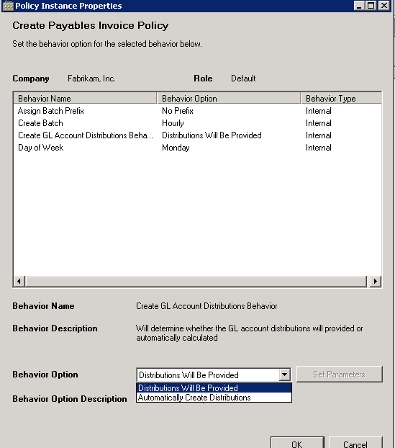

Configuring “Create Sales Invoice Policy”
If you plan to create sales invoice, follow this step (not common). Go to Administrative Tools - > Dynamics Security Console -> MicrosoftDynamicsSecurity - > DynamicsGPWebServices-> Policy ->Sales Document -> Create Sales Invoice Policy
Make sure the following 4 items are set as shown-
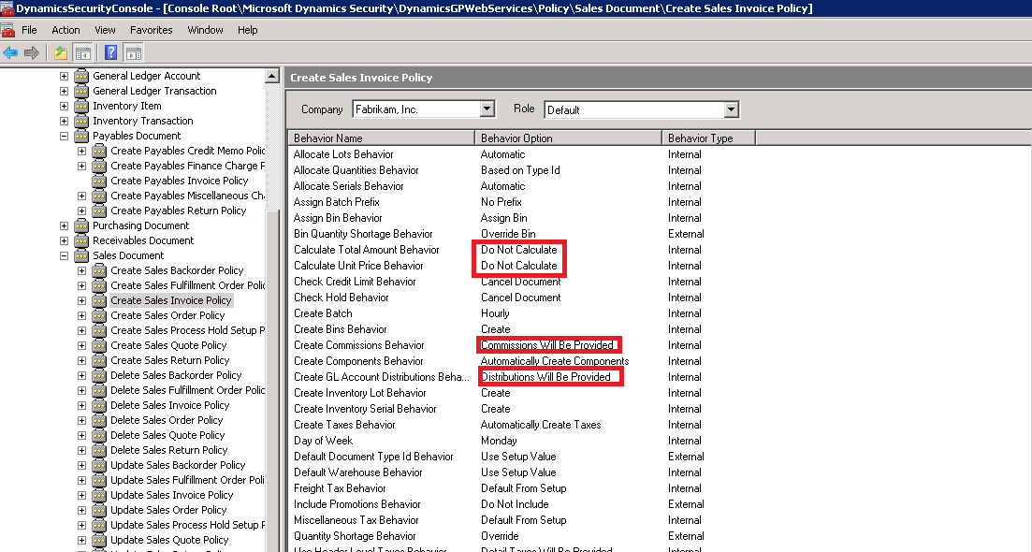

Configuring “Create Purchase Receipt Policy”
If you plan to create purchase receipts, follow this step (not common). Repeat the above for “Create Purchase Receipt Policy” by going to Administrative Tools - > Dynamics Security Console -> MicrosoftDynamicsSecurity - > DynamicsGPWebServices-> Policy ->Purchasing Document

Installing Gorilla Expense Integration App
Pre-requisite – .NET Framework 3.5
Download & Install Gorilla Expense Integration App from the link below –
http://www.gorillaexpense.info/install/publish.htm

Configuring Gorilla Expense Integration App
On the logon screen, enter ADMIN username and password provided in the “Application Access Instructions” file. In the same file, copy the ”Unique Company Specific Login URL” and paste in the URL field on the login screen. Then login. The company specific url should look like the one below –
https://www.gorillaexpense.info/<companyname>/service
Once logged in go to File-> Export Expense Report ->Settings. Please see the red boxes highlighted on the screen below -
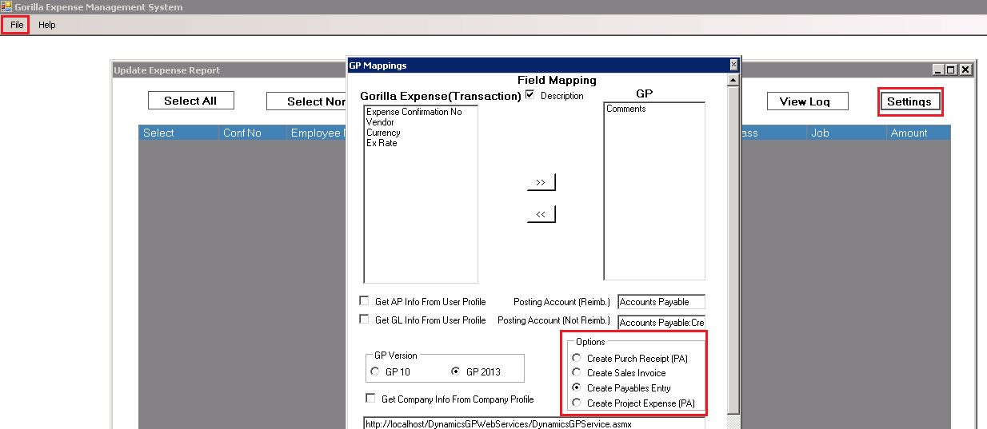

- Select Comments under Field Mapping
- Enter Posting Accounts -> There are two accounts here, one is Reimbursable i.e. AP account for Employee Payables and the other is Not-Reimbursable i.e. AP Account for Credit Card Vendor. Most customers use the same account in these places. If your AP Account varies by user / department, check Get AP Info From User Profile. If you select this, please ensure that AP Account has been associated with your user profiles when the user profiles were setup.
- Select GP GP Version
- Check Create Payables Entry. Check “Create Purchase Receipt” or “Create Sales Invoice” Option ONLY if your system is setup for creating purchase receipts or Sales Invoice. If you are not sure, please contact Gorilla Expense support before changing any values.
- If you have only 1 company in GP do steps 5, 6 and 7. Else, proceed to step 8 after consulting with Gorilla Expense team. There might be special cases where step 8 might not be applicable
- Web Service URL (from page 1 of this document) -> depending on the version of GP you have, enter the URL in the appropriate textbox.
- Enter Company ID (refer step 8 to find company ID)
- Company ID can be found by running the following SQL –
SELECT cmpanyid, cmpnynam, interid
FROM DYNAMICS.dbo.SY01500

- If you have more than 1 GP companies to which expenses will be posted, you may associate the company ID and Web Service URL, directly to the company master page on the web application (instead saving it on the setting screen). To do so, login to the web application as admin (refer Application Access Document for URL and logins), then go to Masters -> Company -> and associate the company ID with the corresponding company. Also, associate the web service URL from page1 of this document with the same company. Please see the screen shot below –
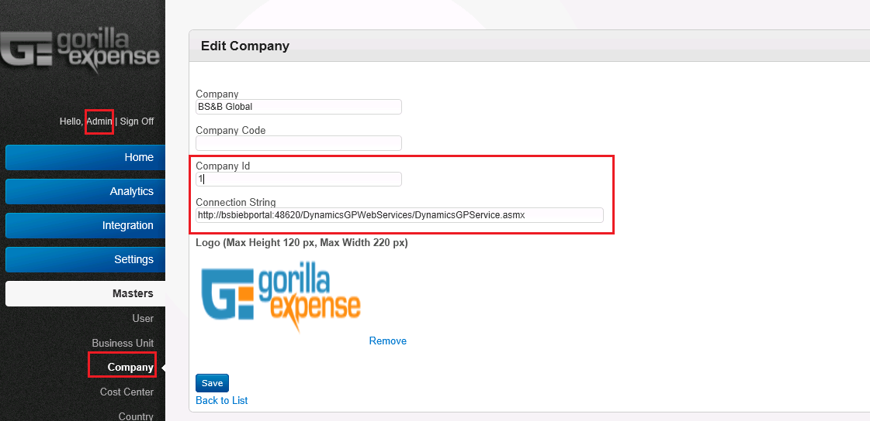
- Then come back to the Integration app-> Settings screen and check “Get Company Info from Company Profile” screen. Please see the two screens below –

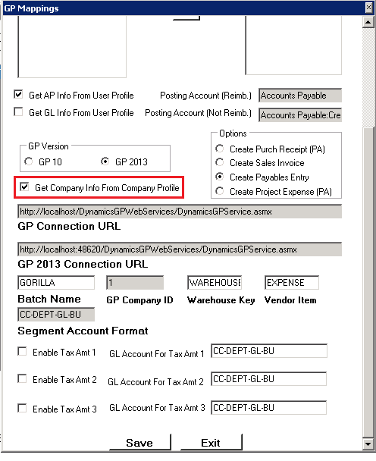

- Ignore the tax amount fields if you do not use VAT / GST or if you are based in USA. IF you use, VAT, Gorilla Expense Support team will configure these fields for you.
- Scroll down and click save

